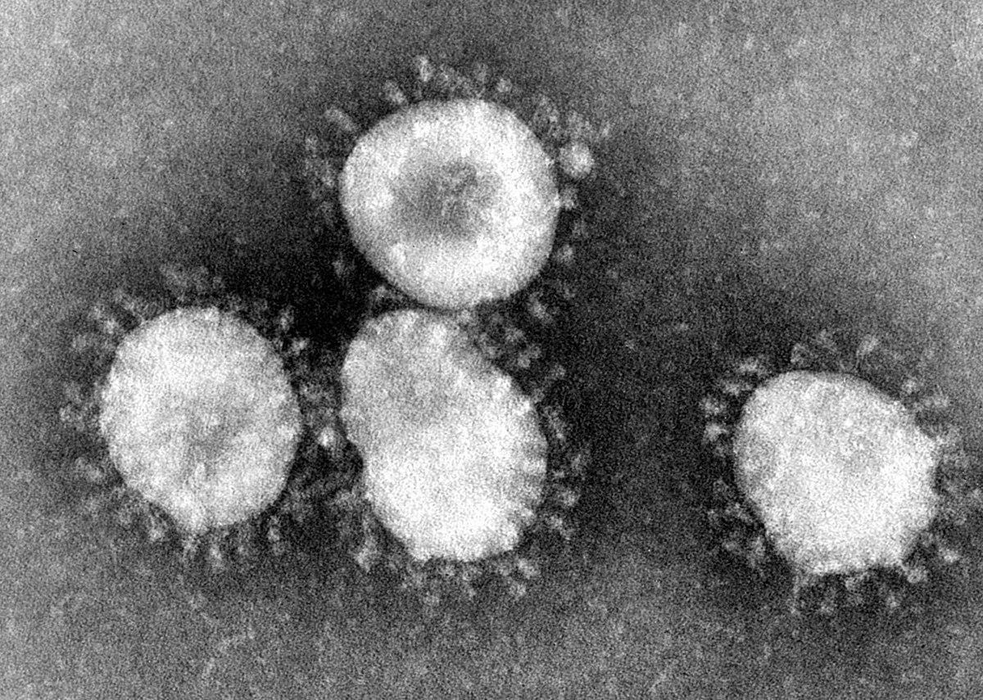

Modeling COVID-19

Jay Choi, James Lawson, Harry Pinkerton, Grace Sullivan

Introduction

Coronavirus disease 2019 (COVID-19) is an infectious respiratory disease caused by the novel coronavirus SARS-CoV-2. Similar to the SARS-CoV and MERS-CoV viruses in 2002 and 2012, respectively, SARS-CoV-2 is a betacoronavirus and its sequence originates in bats. In December 2019, the outbreak began in Wuhan, China and subsequently spread to many other nations in the subsequent months.[1] By the end of January 2020, the World Health Organization (WHO) declared COVID-19 to be a Public Health Emergency of International Concern; on March 11, the WHO declared COVID-19 a pandemic.[2]

COVID-19 has an incubation period of 14 days and its symptoms can include cough, shortness of breath, fever, chills, muscle pain, sore throat, nausea, vomiting, loss of sense of smell and taste, and others.[3] Elderly individuals and those with underlying respiratory and pulmonary conditions are at higher risk for life-threatening complications from the virus.

The coronavirus can be transmitted person-to-person through respiratory droplets or from contact with a surface contaminated with the virus.[4] The transmission can occur when someone speaks, coughs, or sneezes.

Social distancing measures were implemented in the United States in an attempt to flatten the curve and slow down the spread of the virus. By mid-March 2020, many individuals were working remotely and students were receiving virtual instruction. Work, education, and travel had changed drastically by this point, and continues to be limited in harder hit areas of the nation.[5]

Motivation

It is crucial to model the spread of COVID-19, as well as the behavioral patterns of individuals both quarantining and not quarantining in order to effectively combat the virus. By collecting data on COVID-19, researchers and health officials will better be able to monitor infection rates, comprehend risk factors, and predict future transmission patterns.[6]

COVID-19 has completely altered how many regions of the United States currently operate in all facets of life. Nursing homes in particular have been devastated by the disease. Many residents in these communities are elderly with underlying conditions, and living in close quarters amplifies the risk for infection and serious complications.[7]

Fear and panic surrounding the coronavirus has led to shortages not only in food and household items but also in protective gear. Items such as masks, eye shields, and gowns are just a couple of the many personal protective equipment (PPE) items that are in short supply.[8] Modeling the spread and number of individuals infected is crucial to ensure hospitals and medical centers have sufficient supplies to protect themselves and care for the sick.

With the most promising vaccine is only projected to reach the general public at the end of the year, it is clear that we cannot rely on a treatment or vaccine to be the sole solution to slow down this pandemic.[9] In the meantime, our best defense is social distancing and isolation measures, which can be incorporated into models of COVID-19. Practicing social distancing has been shown to minimize the number of individuals who are exposed to the virus, thus minimizing the number of lethal cases of the virus.

Methodology

Our COVID-19 model looks at the potential effects of the pandemic in the United States over a period of 700 days (~2 years). We divide the population of the United States (~300 million) into two groups: the healthy population and the population with underlying conditions. We choose to divide the population in this manner because empirical data has shown that individuals who are already suffering from underlying conditions are at higher risk of death from COVID-19 than those who are not. For simplicity, the underlying conditions we account for in our model are cardiovascular diseases, diabetes, and chronic respiratory disease. We have chosen to incorporate these three underlying conditions because they are most closely tied to a higher risk of death from COVID-19.

In our model, we have two initial populations: the initial population of healthy people (labeled “Init Population”) and the initial population of people with underlying conditions (labeled “Underlying Init Population”). We use the variable “Fraction with Underlying Conditions” as a proportion to represent the proportion of the United States population with underlying conditions. This variable is the sum of three percentages: 9.4%[10], 48%[11], and 6.4%[12]. These percentages represent the proportion of the United States population diagnosed with diabetes, cardiovascular disease, and chronic respiratory disease, respectively.

After dividing the total United States population into the two aforementioned subgroups, we choose to account for the proportion of these populations that have chosen to self-quarantine. According to Changing America, the percentage of Americans undergoing self-quarantine sits at about 75%.[13] Therefore, in our model we assume that 75% of both the healthy population and the underlying conditions population are quarantining. We also make the assumption that because these individuals are in self-quarantine, they will not be at risk of being infected by the virus. As a result, our susceptible healthy population and our underlying susceptible population are 25% of their initial total values. In other words, this is the proportion of the two populations that is susceptible to being infected by COVID-19.

Our model utilizes a universal infection rate of 0.48%, because we believe it is logical that this infection rate will be the same value regardless of whether an individual is healthy or has an underlying condition.[14] Taking into account the susceptible populations, our model uses this infection rate to then determine how many healthy individuals will be infected, and how many individuals with underlying conditions will be infected, respectively. It is important to note here that so far, the processes in our model for our two different populations (healthy vs. underlying conditions) is the same. The real differentiation between these two models is their respective fatality and recovery rates.

For our healthy population, the fatality rate we use is the average infection fatality rate in the United States, 1.3%.[15] Conversely, the recovery rate for this population is equivalent to 1 minus the fatality rate, or 98.7%. For our population with underlying conditions the process of setting the fatality rate in our model was a bit more complex. To calculate this value, we took the weighted average of the fatality rates for individuals with diabetes (7.3%), individuals with cardiovascular disease (10.5%), and individuals with chronic respiratory disease (6.3%).[16] Mathematically, the formula we used to do this is as follows: (9.4×.073+48×.105+6.4×.063) / (9.4+48+6.4) = 0.0960721. Thus, our calculated fatality rate for individuals with underlying conditions in our model is approximately 9.6%.

The values for deaths and recoveries of the healthy population are calculated by simply multiplying the infected population by the fatality rate (for deaths) and multiplying the infected population by 1 minus the fatality rate (for recoveries). Similarly, the values for deaths and recoveries of the population with underlying conditions are calculated by multiplying the infected underlying conditions population by their calculated fatality rate (for deaths) and multiplying the infected underlying conditions population by 1 minus their calculated fatality rate (for recoveries).

As you will see in the results, the way our model is designed demonstrates that the population with underlying conditions will experience a significantly higher number of deaths from COVID-19 than the healthy population. In designing our model this way, we wanted to show the very harmful long-term effects that the COVID-19 pandemic could have on individuals with underlying conditions.

Results

Our results indicated that susceptible populations exponentially decrease nearing zeros as time advances in our model for both susceptible populations and susceptible populations with underlying conditions (Figure 1). The susceptible populations decline as more individuals become infected.

We broke infected populations into a normal infected population and an infected population that had underlying conditions. This graph also exponentially decreases for both the infected population and the infected population with underlying conditions until both graphs approach zero (Figure 2). A possible explanation for this is that people who are infected are either going to recover or die and this cycle decreases the number of people who could contract the virus which leads to additional cases.

We broke deaths into deaths of people with no underlying conditions and deaths of people with underlying conditions. Unlike the previous two graphs, there is a significant difference between deaths with underlying conditions and deaths without underlying conditions (Figure 3). For deaths without underlying conditions, the graph starts at zero and slowly increases at a weak linear rate. For deaths with underlying conditions, the graph also starts at zero and quickly increases before flattening out. A possible explanation for this is that people with underlying conditions are much more likely to die from this virus, while people without underlying conditions have a much lower mortality rate.

We broke recoveries into recovered with an underlying condition and recovered without an underlying condition. Both graphs start at zero and then increase quickly before leveling off Figure 4). The graph for recovered with underlying conditions is much higher when compared to the graph of people without underlying conditions. A possible explanation for this is that many more people with underlying conditions might become infected, therefore more of them will recover when compared to patients without underlying conditions.

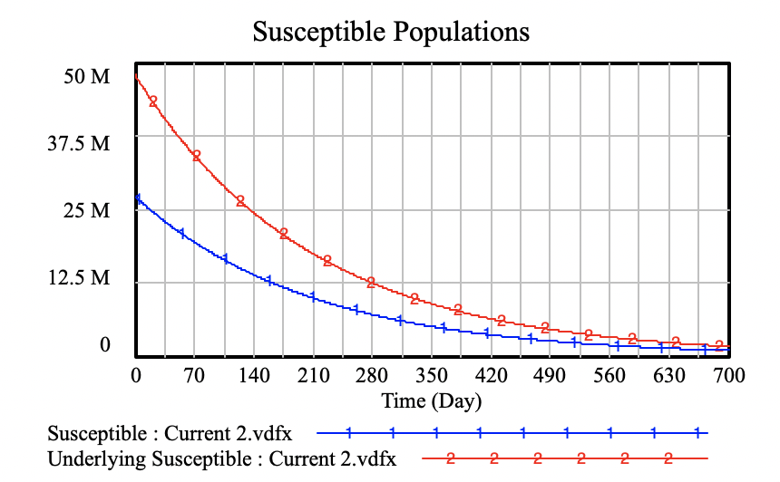

Figure 1. Susceptible Populations for both healthy populations and populations with underlying conditions.

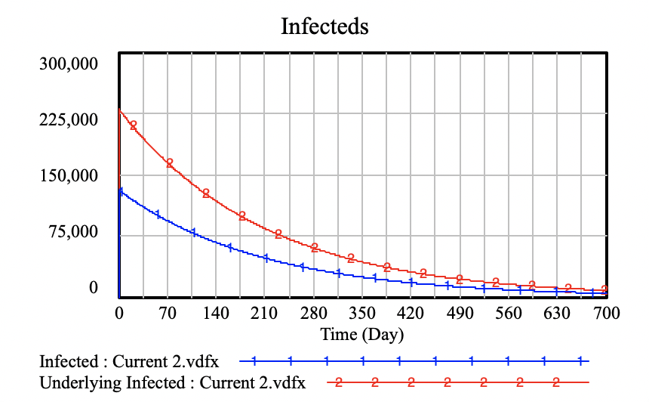

Figure 2. Number of infected individuals in healthy population and population with underlying conditions.

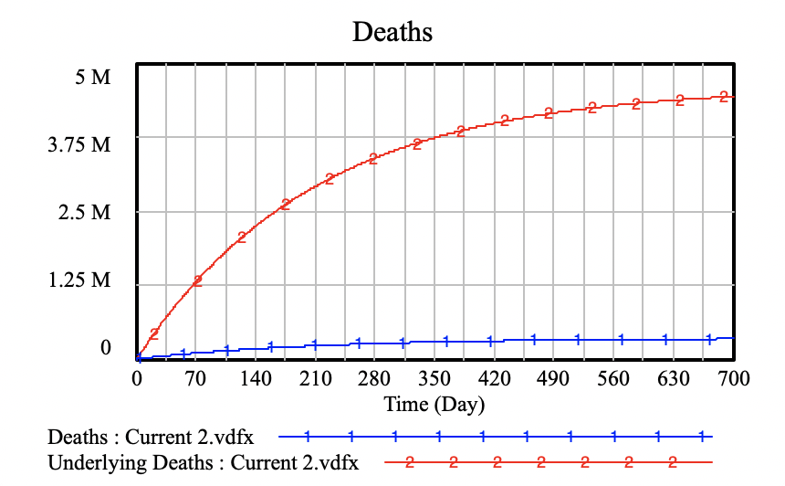

Figure 3. Number of deaths within the healthy population and population with underlying conditions.

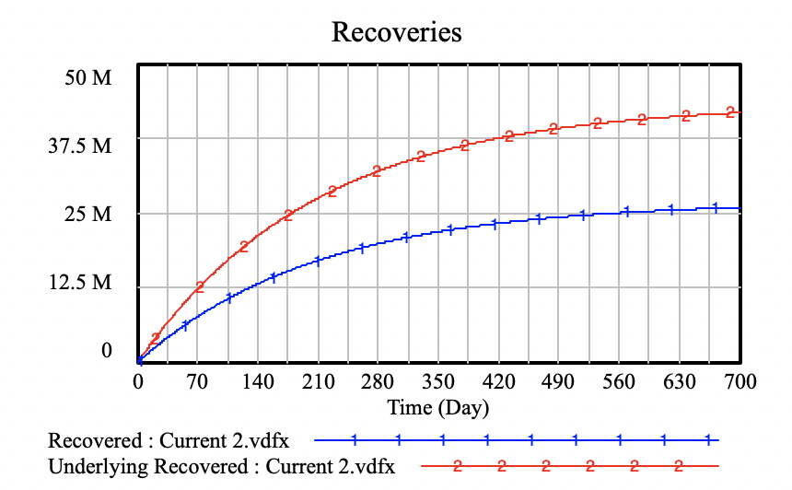

Figure 4. Number of recoveries for healthy population and population with underlying conditions.

Conclusion

While it is impossible to predict the exact course of this virus, our models and ones similar to it can lend insight to how we should respond. Looking at our model, one of the biggest insights is how large of a difference in deaths there is between patients with underlying conditions and patients without underlying conditions. A point that should be emphasized is that patients with underlying conditions must be protected, especially as states continue to open.

1. <https://www.cdc.gov/coronavirus/2019-ncov/cases-updates/summary.html#emergence>
2. <https://www.who.int/news-room/detail/27-04-2020-who-timeline---covid-19>
3. <https://www.cdc.gov/coronavirus/2019-ncov/symptoms-testing/symptoms.html>
4. <https://www.cdc.gov/coronavirus/2019-ncov/hcp/infection-control-recommendations.html>
5. <https://graphics.reuters.com/HEALTH-CORONAVIRUS/USA/qmypmkmwpra/>
6. <https://www.cdc.gov/coronavirus/2019-ncov/covid-data/faq-surveillance.html>
7. <https://www.cdc.gov/coronavirus/2019-ncov/hcp/nursing-homes-testing.html>
8. <https://time.com/5823983/coronavirus-ppe-shortage/>
9. <https://www.nytimes.com/2020/05/18/health/coronavirus-vaccine-moderna.html>
10. <https://www.cdc.gov/media/releases/2017/p0718-diabetes-report.html>
11. <https://www.sciencedaily.com/releases/2019/01/190131084238.htm>
12. <https://www.cdc.gov/copd/basics-about.html>
13. <https://thehill.com/changing-america/well-being/medical-advances/491760-3-in-4-americans-say-they-are-self-isolating-in>
14. <https://legalaidnyc.org/covid-19-infection-tracking-in-nyc-jails/>
15. <https://www.healthaffairs.org/doi/full/10.1377/hlthaff.2020.00455>
16. <https://www.statnews.com/2020/03/03/who-is-getting-sick-and-how-sick-a-breakdown-of-coronavirus-risk-by-demographic-factors/>